TEAM ID | SWTID-2026-6798
PROJECT TITLE | Comprehensive Analysis and Dietary Strategies with Tableau: A College Food Choices Case Study
MAX MARKS | 3 MARKS

6.4 – Dashboard
Click the new dashboard icon.
A blank Dashboard will open.
From the left panel, drag your worksheet on to dashboard .
Arrange them in the desired layout.
Text(for titles).
Image(such as a logo)
Click the drop down arrow on a chart.
Adjust the colors, fonts and border.
Resize the charts and readability.

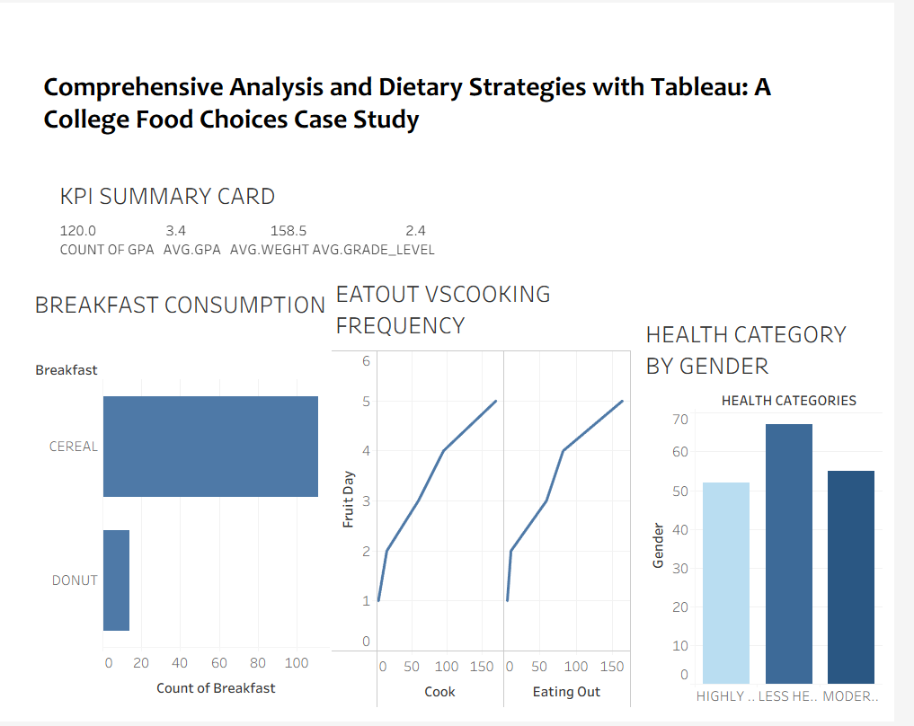

Again Click the new dashboard icon.
A blank Dashboard will open.
From the left panel, drag your worksheet on to dashboard .
Arrange them in the desired layout.
Text(for titles).
Image (such as a logo).
Click the drop down arrow on a chart.
Adjust the colors, fonts and border.
Resize the charts and readability.
